**1) Install Terraform on your PC**

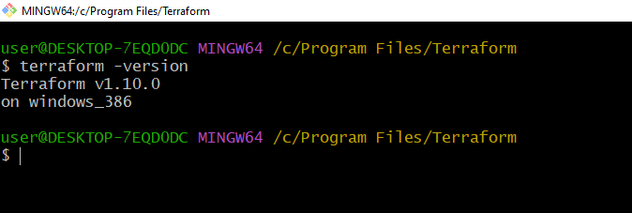

**2) Execute all the templates shown in video.**

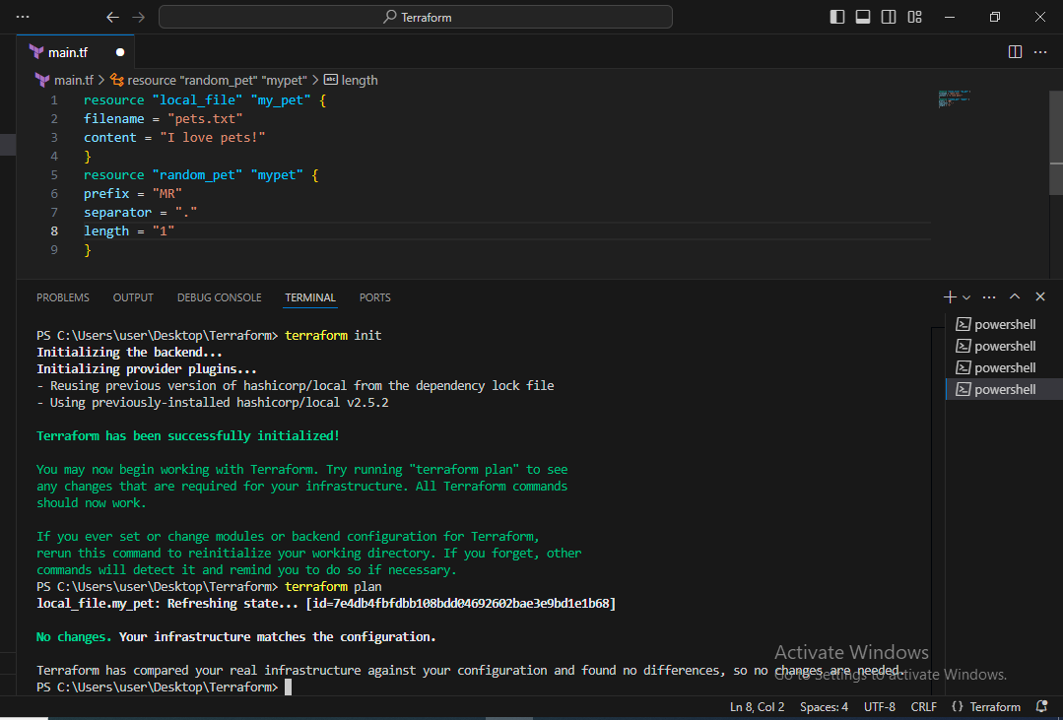

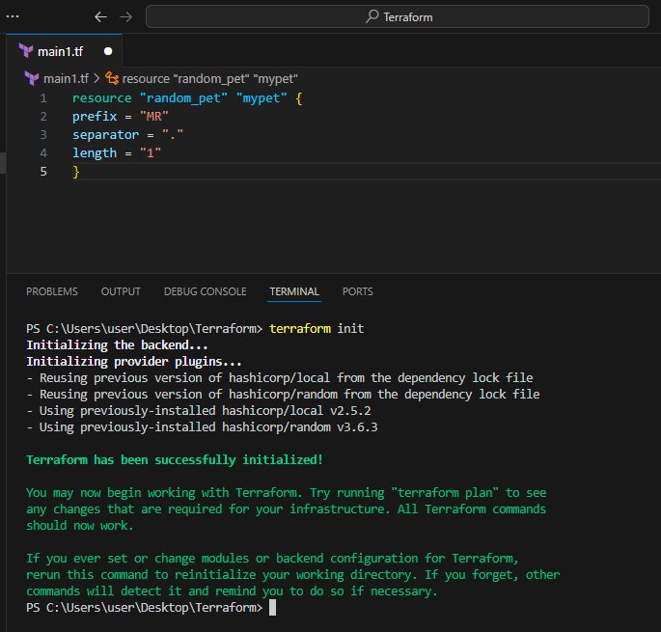

**3) Note down below points, Terraform Init Terraform Plan Terraform Apply Terraform Provider.**

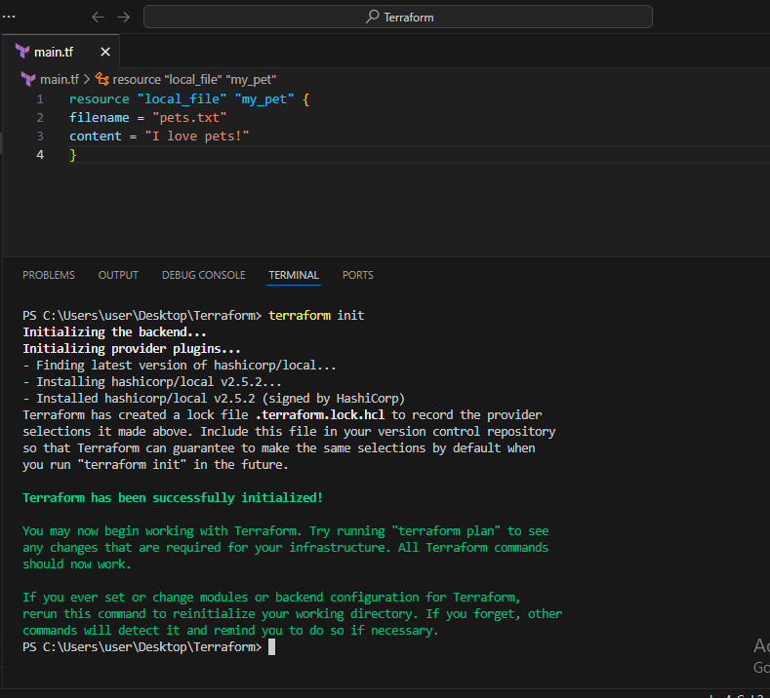

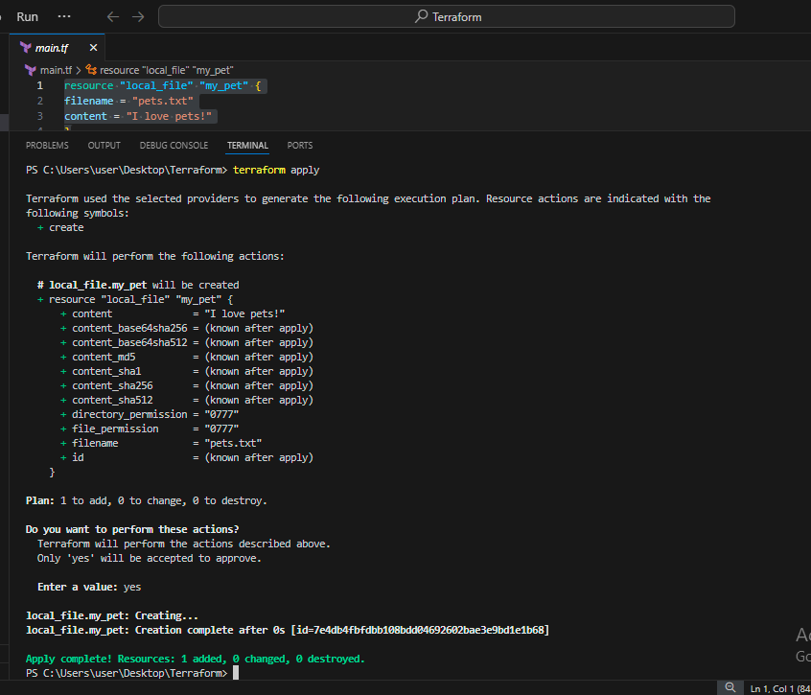

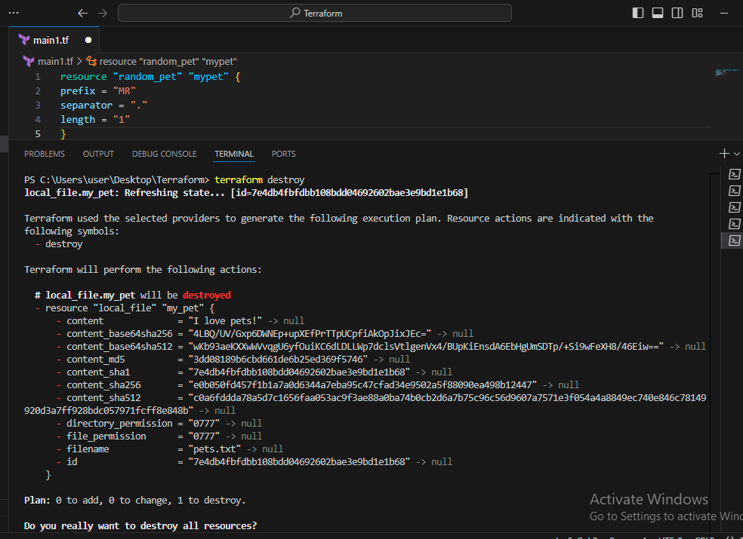

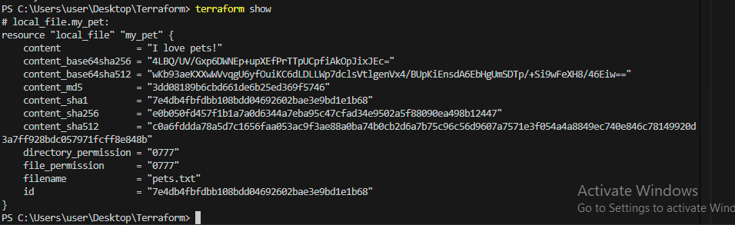

**4) Integrate a sample Terraform template in jenkins.**

**5) Watch the terraform-02 video.**

**6) Execute all the templates shown in video.**

**7) Integrate terraform in jenkins using Terraform plugin.**